MODELAMIENTO HIDRAULICO HEC -RAS

PUENTE PARIACOTO

: Plan 01 River: GRANDE Reach:TRAMO UNICO Riv Sta: 50 Profile: PF 1 E.G. Elev (m) | 1242.76 | Element | Left OB | Channel | Right OB
Vel Head (m) | 1.69 | Wt. n-Val. |  | 0.050
W.S. Elev (m) | 1241.07 | Reach Len. (m) | 50.00 | 50.00 | 50.00
Crit W.S. (m) | 1241.57 | Flow Area (m2) |  | 16.87
E.G. Slope (m/m) | 0.090019 | Area (m2) |  | 16.87
Q Total (m3/seg) | 175.90 | Flow (m3/seg) |  | 175.90
Top Width (m) | 12.14 | Top Width (m) |  | 12.14
Vel Total (m/s) | 10.43 | Avg. Vel. (m/seg) |  | 10.43
Max Chl Dpth (m) | 2.07 | Hydr. Depth (m) |  | 1.39
Conv. Total (m3/seg) | 586.3 | Conv. (m3/seg) |  | 586.3
Length Wtd. (m) |  | Wetted Per. (m) |  | 13.34
Min Ch El (m) | 1239.00 | Shear (N/m2) |  | 7.11
Alpha | 1.00 | Stream Power (N/m s) |  | 74.12
Frctn Loss (m) |  | Cum Volume (1000 m3) | 0.00 | 0.02 | 0.00
C & E Loss (m) |  | Cum SA (1000 m2) | 0.00 | 0.02 | 0.00

CALCULO HEC RAS
RAS Plan: Plan 01 River: GRANDE Reach: TRAMO UNICOReach | River Sta | Q Total | Min Ch El | W.S. Elev | Crit W.S. | E.G. Elev | E.G. Slope | Vel Chnl | Flow Area | Top Width | Froude # Chl
 |  | (m3/s) | (m) | (m) | (m) | (m) | (m/m) | (m/s) | (m2) | (m)
TRAMO UNICO | 50 | 175.90 | 1239.00 | 1241.07 | 1241.57 | 1242.76 | 0.090019 | 10.43 | 16.87 | 12.14 | 1.56
TRAMO UNICO | 0 | 175.90 | 1240.00 | 1242.12 | 1242.12 | 1242.98 | 0.034625 | 7.43 | 23.69 | 14.21 | 1.01

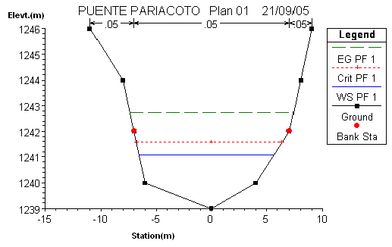

TAQUILMA 1
: Plan 04 River: GRANDE Reach:TRAMO UNICO Riv Sta: 308 Profile: PF 1 E.G. Elev (m) | 1569.56 | Element | Left OB | Channel | Right OB
Vel Head (m) | 1.09 | Wt. n-Val. |  | 0.050
W.S. Elev (m) | 1568.47 | Reach Len. (m) | 308.00 | 308.00 | 308.00
Crit W.S. (m) | 1568.76 | Flow Area (m2) |  | 17.43
E.G. Slope (m/m) | 0.090028 | Area (m2) |  | 17.43
Q Total (m3/seg) | 146.34 | Flow (m3/seg) |  | 146.34
Top Width (m) | 18.00 | Top Width (m) |  | 18.00
Vel Total (m/s) | 8.40 | Avg. Vel. (m/seg) |  | 8.40
Max Chl Dpth (m) | 1.47 | Hydr. Depth (m) |  | 0.97
Conv. Total (m3/seg) | 487.7 | Conv. (m3/seg) |  | 487.7
Length Wtd. (m) |  | Wetted Per. (m) |  | 19.07
Min Ch El (m) | 1567.00 | Shear (N/m2) |  | 5.14
Alpha | 1.00 | Stream Power (N/m s) |  | 43.12
Frctn Loss (m) |  | Cum Volume (1000 m3) |  | 0.14
C & E Loss (m) |  | Cum SA (1000 m2) |  | 0.12

RAS Plan: Plan 04 River: GRANDE Reach: TRAMO UNICOReach | River Sta | Q Total | Min Ch El | W.S. Elev | Crit W.S. | E.G. Elev | E.G. Slope | Vel Chnl | Flow Area | Top Width | Froude # Chl
 |  | (m3/s) | (m) | (m) | (m) | (m) | (m/m) | (m/s) | (m2) | (m)
TRAMO UNICO | 308 | 146.34 | 1567.00 | 1568.47 | 1568.76 | 1569.56 | 0.090028 | 8.40 | 17.43 | 18.00 | 1.50
TRAMO UNICO | 0 | 146.34 | 1583.00 | 1585.66 | 1585.66 | 1586.34 | 0.036382 | 6.63 | 22.07 | 16.61 | 1.01

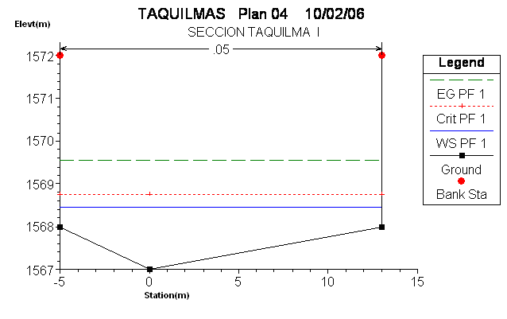

TAQUILMA 2
: Plan 04 River: GRANDE Reach:TRAMO UNICO Riv Sta: 0 Profile: PF 1 E.G. Elev (m) | 1586.34 | Element | Left OB | Channel | Right OB
Vel Head (m) | 0.68 | Wt. n-Val. |  | 0.050
W.S. Elev (m) | 1585.66 | Reach Len. (m)
Crit W.S. (m) | 1585.66 | Flow Area (m2) |  | 22.07
E.G. Slope (m/m) | 0.036382 | Area (m2) |  | 22.07
Q Total (m3/seg) | 146.34 | Flow (m3/seg) |  | 146.34
Top Width (m) | 16.61 | Top Width (m) |  | 16.61
Vel Total (m/s) | 6.63 | Avg. Vel. (m/seg) |  | 6.63
Max Chl Dpth (m) | 2.66 | Hydr. Depth (m) |  | 1.33
Conv. Total (m3/seg) | 767.2 | Conv. (m3/seg) |  | 767.2
Length Wtd. (m) |  | Wetted Per. (m) |  | 17.44
Min Ch El (m) | 1583.00 | Shear (N/m2) |  | 2.87
Alpha | 1.00 | Stream Power (N/m s) |  | 19.06
Frctn Loss (m) |  | Cum Volume (1000 m3)
C & E Loss (m) |  | Cum SA (1000 m2)

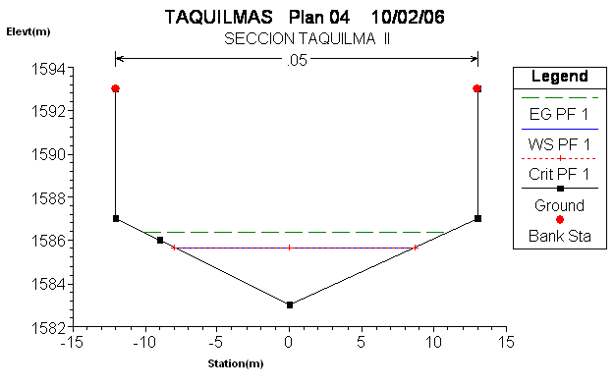

CHACCHAN 1
: Plan 01 River: CHACCHAN Reach:TRAMO UNICO Riv Sta: 0 Profile: PF 1 E.G. Elev (m) | 2145.20 | Element | Left OB | Channel | Right OB
Vel Head (m) | 2.33 | Wt. n-Val. |  | 0.050
W.S. Elev (m) | 2142.87 | Reach Len. (m)
Crit W.S. (m) | 2143.50 | Flow Area (m2) |  | 19.73
E.G. Slope (m/m) | 0.231211 | Area (m2) |  | 19.73
Q Total (m3/seg) | 241.60 | Flow (m3/seg) |  | 241.60
Top Width (m) | 24.47 | Top Width (m) |  | 24.47
Vel Total (m/s) | 12.24 | Avg. Vel. (m/seg) |  | 12.24
Max Chl Dpth (m) | 0.87 | Hydr. Depth (m) |  | 0.81
Conv. Total (m3/seg) | 502.4 | Conv. (m3/seg) |  | 502.4
Length Wtd. (m) |  | Wetted Per. (m) |  | 24.88
Min Ch El (m) | 2142.00 | Shear (N/m2) |  | 11.45
Alpha | 1.00 | Stream Power (N/m s) |  | 140.16
Frctn Loss (m) | 68.41 | Cum Volume (1000 m3)
C & E Loss (m) | 0.12 | Cum SA (1000 m2)

RAS Plan: Plan 01 River: CHACCHAN Reach: TRAMO UNICOReach | River Sta | Q Total | Min Ch El | W.S. Elev | Crit W.S. | E.G. Elev | E.G. Slope | Vel Chnl | Flow Area | Top Width | Froude # Chl
 |  | (m3/s) | (m) | (m) | (m) | (m) | (m/m) | (m/s) | (m2) | (m)
TRAMO UNICO | 1875 | 241.60 | 2318.00 | 2319.64 | 2320.65 | 2323.27 | 0.200185 | 15.30 | 15.79 | 11.28 | 2.28
TRAMO UNICO | 860 | 241.60 | 2209.00 | 2212.57 | 2212.57 | 2213.69 | 0.040245 | 8.48 | 28.48 | 12.84 | 1.00
TRAMO UNICO | 0 | 241.60 | 2142.00 | 2142.87 | 2143.50 | 2145.20 | 0.231211 | 12.24 | 19.73 | 24.47 | 2.40

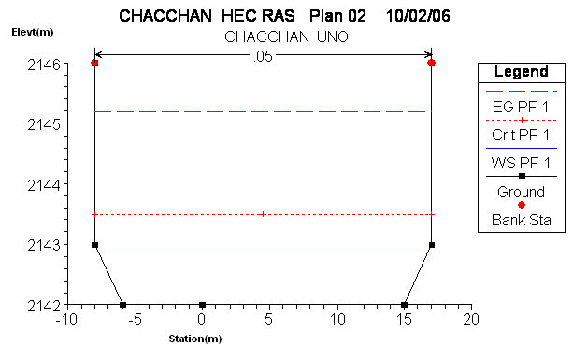

CHACCHAN 2
: Plan 01 River: CHACCHAN Reach:TRAMO UNICO Riv Sta: 860 Profile: PF 1 E.G. Elev (m) | 2213.69 | Element | Left OB | Channel | Right OB
Vel Head (m) | 1.12 | Wt. n-Val. |  | 0.050
W.S. Elev (m) | 2212.57 | Reach Len. (m) | 860.00 | 860.00 | 860.00
Crit W.S. (m) | 2212.57 | Flow Area (m2) |  | 28.48
E.G. Slope (m/m) | 0.040245 | Area (m2) |  | 28.48
Q Total (m3/seg) | 241.60 | Flow (m3/seg) |  | 241.60
Top Width (m) | 12.84 | Top Width (m) |  | 12.84
Vel Total (m/s) | 8.48 | Avg. Vel. (m/seg) |  | 8.48
Max Chl Dpth (m) | 3.57 | Hydr. Depth (m) |  | 2.22
Conv. Total (m3/seg) | 1204.3 | Conv. (m3/seg) |  | 1204.3
Length Wtd. (m) | 860.00 | Wetted Per. (m) |  | 16.77
Min Ch El (m) | 2209.00 | Shear (N/m2) |  | 4.27
Alpha | 1.00 | Stream Power (N/m s) |  | 36.19
Frctn Loss (m) | 32.36 | Cum Volume (1000 m3) |  | 0.48
C & E Loss (m) | 0.12 | Cum SA (1000 m2) |  | 0.37

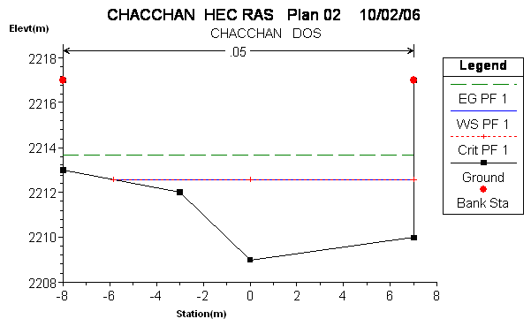
CHACCHAN 3
: Plan 01 River: CHACCHAN Reach:TRAMO UNICO Riv Sta: 1875 Profile: PF 1 E.G. Elev (m) | 2323.27 | Element | Left OB | Channel | Right OB
Vel Head (m) | 3.64 | Wt. n-Val. |  | 0.050
W.S. Elev (m) | 2319.64 | Reach Len. (m) | 1875.00 | 1875.00 | 1875.00
Crit W.S. (m) | 2320.65 | Flow Area (m2) |  | 15.79
E.G. Slope (m/m) | 0.200185 | Area (m2) |  | 15.79
Q Total (m3/seg) | 241.60 | Flow (m3/seg) |  | 241.60
Top Width (m) | 11.28 | Top Width (m) |  | 11.28
Vel Total (m/s) | 15.30 | Avg. Vel. (m/seg) |  | 15.30
Max Chl Dpth (m) | 1.64 | Hydr. Depth (m) |  | 1.40
Conv. Total (m3/seg) | 540.0 | Conv. (m3/seg) |  | 540.0
Length Wtd. (m) | 1875.00 | Wetted Per. (m) |  | 12.78
Min Ch El (m) | 2318.00 | Shear (N/m2) |  | 15.43
Alpha | 1.00 | Stream Power (N/m s) |  | 236.18
Frctn Loss (m) |  | Cum Volume (1000 m3) |  | 1.43
C & E Loss (m) |  | Cum SA (1000 m2) |  | 0.89
