

Project Summary
Project name: Puente Tingo-ok.ttp
Created by: Juan G. Castillo Coaquira
Comment:
Linear unit: Meters
GPS Obs Quality
Name | dN (m) | dE (m) | dHt (m) | Horz RMS (m) | Vert RMS (m)
26-P1−BM-CB-1 IGN | 13565.5753 | 1274.1552 | 802.4949 | 0.0073 | 0.0105
26-P1−Cajamarca | 14683.1252 | 2169.1510 | 790.4580 | 0.0070 | 0.0087
26-P1−T-1 | 362.1503 | -128.6480 | 0.7347 | 0.0010 | 0.0014
26-P1−T-2 | 388.8969 | 21.6351 | -11.3009 | 0.0011 | 0.0018
BM-CB-1 IGN−Cajamarca | 1117.5453 | 894.9854 | -12.0479 | 0.0009 | 0.0014
BM-CB-1 IGN−T-1 | -13203.4206 | -1402.8101 | -801.7104 | 0.0097 | 0.0179
BM-CB-1 IGN−T-2 | -13176.6485 | -1252.5374 | -813.7921 | 0.0072 | 0.0126
Cajamarca−T-1 | -14320.9704 | -2297.8023 | -789.7119 | 0.0067 | 0.0102
Cajamarca−T-2 | -14294.2189 | -2147.5326 | -801.7909 | 0.0054 | 0.0093

Adjusted Point Quality
Name | Grid Northing (m) | Grid Easting (m) | Elevation (m) | Code
26−P1 | 9194588.7611 | 772920.5442 | 1919.4897
BM−CB−1 IGN | 9208154.3327 | 774194.7107 | 2721.9038
T−1 | 9194950.9111 | 772791.8963 | 1920.2275
T−2 | 9194977.6599 | 772942.1783 | 1908.1849

Identical Points
Point 1 | Point 2 | Distance (m)
26-P1 | T-1 | 0.0001
26-P1 | T-2 | 0.0001
BM-CB-1 IGN | Cajamarca | 0.0002
T-1 | T-2 | 0.0000

Misnamed GPS Occupations
Point Name | Original Name | Start Time | Nav Distance from Point (m.)
no data met
Adjusted Point Quality
Name | WGS84 Latitude | WGS84 Longitude | WGS84 Ell.Height (m) | Code
26−P1 | 7°16'46.790924"S | 78°31'41.814466"W | 1939.0424
BM−CB−1 IGN | 7°09'25.216006"S | 78°31'02.706560"W | 2741.5443
T−1 | 7°16'35.031400"S | 78°31'46.070688"W | 1939.7785
T−2 | 7°16'34.134412"S | 78°31'41.178865"W | 1927.7395

Identical Points
Point 1 | Point 2 | Distance (m)
26-P1 | T-1 | 0.0001
26-P1 | T-2 | 0.0001
BM-CB-1 IGN | Cajamarca | 0.0002
T-1 | T-2 | 0.0000

Project Summary
Project name: Puente Tingo-ok.ttp
Surveyor: Juan G. Castillo Coaquira
Comment:
Linear unit: Meters
Projection: UTMSouth-Zone_17 : 84W to 78W
Geoid: EGM96_Peru
Points
Name | Grid Northing (m) | Grid Easting (m) | Elevation (m) | Code | Combined Grid to Ground Scale Factor | Combined Ground to Grid Scale Factor | Geoid Separation (m) | Convergence
26−P1 | 9194588.7611 | 772920.5442 | 1919.4897 |  | 0.999782490433 | 1.000217556887946 | 19.5527 | -0°18'48.2142"
BM−CB−1 IGN | 9208154.3327 | 774194.7107 | 2721.9038 |  | 0.999899754895 | 1.000100255154840 | 19.6405 | -0°18'34.1860"
Cajamarca | 9209271.8793 | 775089.6970 | 2709.8372 |  | 0.999891782434 | 1.000108229278150 | 19.6610 | -0°18'36.2245"
T−1 | 9194950.9111 | 772791.8963 | 1920.2275 |  | 0.999783474221 | 1.000216572672927 | 19.5510 | -0°18'47.1706"
T−2 | 9194977.6599 | 772942.1783 | 1908.1849 |  | 0.999780570963 | 1.000219477196837 | 19.5546 | -0°18'47.7530"

Points
Name | WGS84 Latitude | WGS84 Longitude | WGS84 Ell.Height (m) | Code | Combined Grid to Ground Scale Factor | Combined Ground to Grid Scale Factor | Geoid Separation (m) | Convergence
26−P1 | 7°16'46.790924"S | 78°31'41.814466"W | 1939.0424 |  | 0.999782490433 | 1.000217556887946 | 19.5527 | -0°18'48.2142"
BM−CB−1 IGN | 7°09'25.216006"S | 78°31'02.706560"W | 2741.5443 |  | 0.999899754895 | 1.000100255154840 | 19.6405 | -0°18'34.1860"
Cajamarca | 7°08'48.699870"S | 78°30'33.750640"W | 2729.4982 |  | 0.999891782434 | 1.000108229278150 | 19.6610 | -0°18'36.2245"
T−1 | 7°16'35.031400"S | 78°31'46.070688"W | 1939.7785 |  | 0.999783474221 | 1.000216572672927 | 19.5510 | -0°18'47.1706"
T−2 | 7°16'34.134412"S | 78°31'41.178865"W | 1927.7395 |  | 0.999780570963 | 1.000219477196837 | 19.5546 | -0°18'47.7530"

Project Summary
Project name: Puente Tingo-ok.ttp
Surveyor: Juan G. Castillo Coaquira
Comment:
Linear unit: Meters
Projection: UTMSouth-Zone_17 : 84W to 78W
Geoid: EGM96_Peru
GPS Observation Residuals
Name | dN (m) | dE (m) | dHt (m) | Horz RMS (m) | Vert RMS (m) | GPS Satellites | GLONASS Satellites | Solution Type | SigmaX (m) | SigmaY (m) | SigmaZ (m) | CorrXY | CorrXZ | CorrYZ | PDOP
26-P1−BM-CB-1 IGN | 13565.5753 | 1274.1552 | 802.4949 | 0.0073 | 0.0105 | 12 | 0 | Fixed,Iono Free | 0.0070 | 0.0100 | 0.0037 | -0.3810 | 0.1041 | 0.3430 | 4.346
26-P1−Cajamarca | 14683.1252 | 2169.1510 | 790.4580 | 0.0070 | 0.0087 | 15 | 6 | Fixed,Iono Free | 0.0061 | 0.0087 | 0.0034 | -0.0005 | 0.2185 | 0.3875 | 2.112
26-P1−T-1 | 362.1503 | -128.6480 | 0.7347 | 0.0010 | 0.0014 | 10 | 4 | Fixed | 0.0010 | 0.0014 | 0.0004 | -0.2650 | -0.4330 | 0.2756 | 2.711
26-P1−T-2 | 388.8969 | 21.6351 | -11.3009 | 0.0011 | 0.0018 | 9 | 4 | Fixed | 0.0008 | 0.0018 | 0.0007 | 0.3026 | -0.1146 | 0.4712 | 2.420
BM-CB-1 IGN−Cajamarca | 1117.5453 | 894.9854 | -12.0479 | 0.0009 | 0.0014 | 14 | 0 | Fixed | 0.0008 | 0.0013 | 0.0005 | -0.3179 | -0.0900 | 0.1808 | 2.445
BM-CB-1 IGN−T-1 | -13203.4206 | -1402.8101 | -801.7104 | 0.0097 | 0.0179 | 7 | 0 | Fixed,Iono Free | 0.0105 | 0.0168 | 0.0048 | -0.5662 | -0.3747 | 0.4690 | 7.900
BM-CB-1 IGN−T-2 | -13176.6485 | -1252.5374 | -813.7921 | 0.0072 | 0.0126 | 6 | 0 | Fixed,Iono Free | 0.0046 | 0.0133 | 0.0036 | 0.3226 | 0.0083 | -0.1333 | 8.478
Cajamarca−T-1 | -14320.9704 | -2297.8023 | -789.7119 | 0.0067 | 0.0102 | 10 | 4 | Fixed,Iono Free | 0.0063 | 0.0099 | 0.0032 | -0.1860 | -0.2424 | 0.5588 | 2.473
Cajamarca−T-2 | -14294.2189 | -2147.5326 | -801.7909 | 0.0054 | 0.0093 | 9 | 4 | Fixed,Iono Free | 0.0037 | 0.0096 | 0.0031 | 0.3138 | -0.0210 | 0.3745 | 2.337

Control Points
Name | Grid Northing (m) | Grid Easting (m) | Elevation (m) | Code | Combined Grid to Ground Scale Factor | Combined Ground to Grid Scale Factor
Cajamarca | 9209271.8793 | 775089.6970 | 2709.8372 |  | 0.999891782434 | 1.000108229278150

Control Points
Name | WGS84 Latitude | WGS84 Longitude | WGS84 Ell.Height (m) | Code | Combined Grid to Ground Scale Factor | Combined Ground to Grid Scale Factor
Cajamarca | 7°08'48.699870"S | 78°30'33.750640"W | 2729.4982 |  | 0.999891782434 | 1.000108229278150

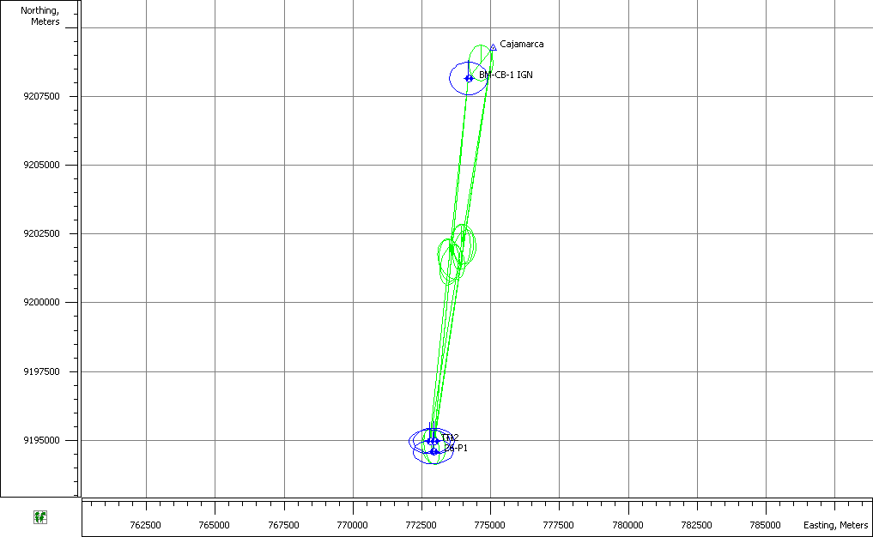
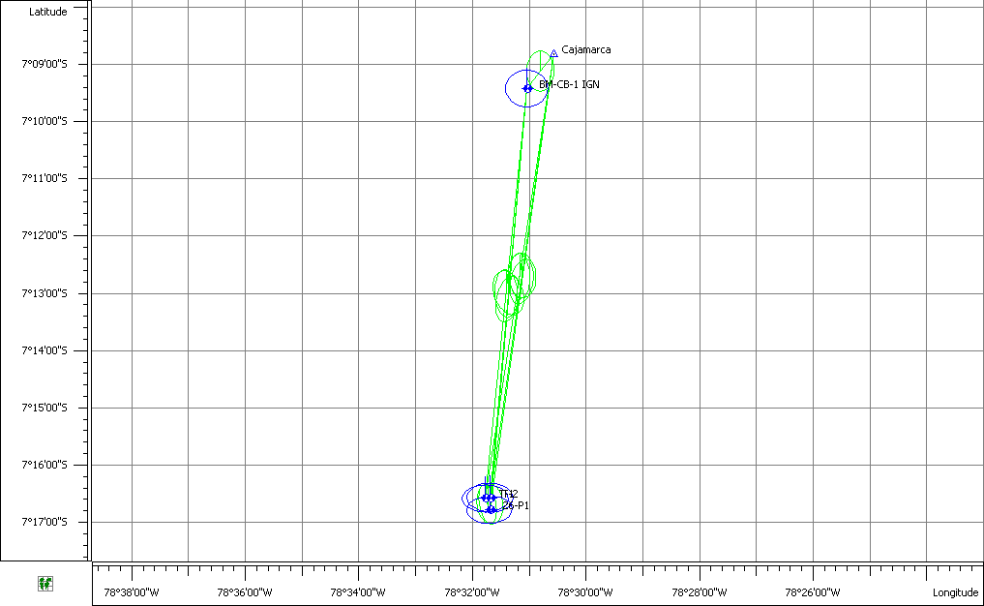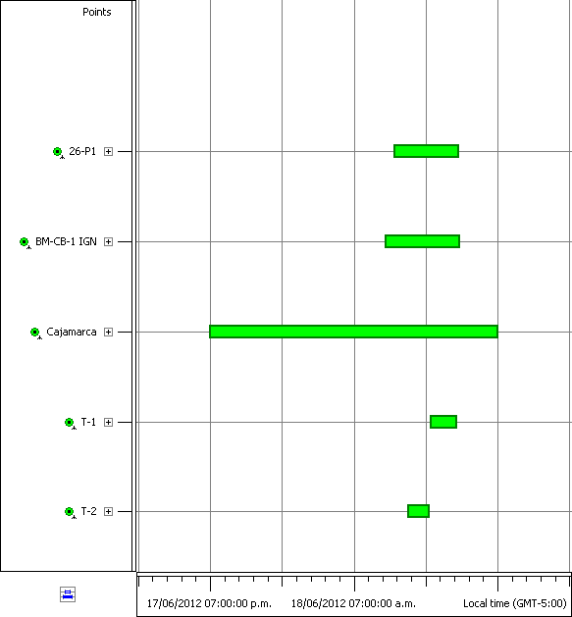

Project Summary
Project name: Puente Tingo-ok.ttp
Surveyor: Juan G. Castillo Coaquira
Comment:
Linear unit: Meters
GPS Observations
Name | dN (m) | dE (m) | dHt (m) | Horz RMS (m) | Vert RMS (m)
26-P1−BM-CB-1 IGN | 13565.5753 | 1274.1552 | 802.4949 | 0.0073 | 0.0105
26-P1−Cajamarca | 14683.1252 | 2169.1510 | 790.4580 | 0.0070 | 0.0087
26-P1−T-1 | 362.1503 | -128.6480 | 0.7347 | 0.0010 | 0.0014
26-P1−T-2 | 388.8969 | 21.6351 | -11.3009 | 0.0011 | 0.0018
BM-CB-1 IGN−Cajamarca | 1117.5453 | 894.9854 | -12.0479 | 0.0009 | 0.0014
BM-CB-1 IGN−T-1 | -13203.4206 | -1402.8101 | -801.7104 | 0.0097 | 0.0179
BM-CB-1 IGN−T-2 | -13176.6485 | -1252.5374 | -813.7921 | 0.0072 | 0.0126
Cajamarca−T-1 | -14320.9704 | -2297.8023 | -789.7119 | 0.0067 | 0.0102
Cajamarca−T-2 | -14294.2189 | -2147.5326 | -801.7909 | 0.0054 | 0.0093

Project Summary
Project name: Puente Tingo-ok.ttp
Surveyor: Juan G. Castillo Coaquira
Comment:
Linear unit: Meters
Projection: UTMSouth-Zone_17 : 84W to 78W
Geoid: EGM96_Peru
Adjustment Summary
Adjustment type: Plane + Height, Minimal constraint
Confidence level: 95 %
Number of adjusted points: 5
Number of plane control points: 1
Number of used GPS vectors: 9
A posteriori plane UWE: 2.437227 , Bounds: ( 0.5700877 , 1.431083 )
Number of height control points: 1
A posteriori height UWE: 2.214604 , Bounds: ( 0.4076763 , 1.601874 )
Used GPS Observations
Name | dN (m) | dE (m) | dHt (m) | Horz RMS (m) | Vert RMS (m)
26-P1−BM-CB-1 IGN | 13565.5753 | 1274.1552 | 802.4949 | 0.0073 | 0.0105
26-P1−Cajamarca | 14683.1252 | 2169.1510 | 790.4580 | 0.0070 | 0.0087
26-P1−T-1 | 362.1503 | -128.6480 | 0.7347 | 0.0010 | 0.0014
26-P1−T-2 | 388.8969 | 21.6351 | -11.3009 | 0.0011 | 0.0018
BM-CB-1 IGN−Cajamarca | 1117.5453 | 894.9854 | -12.0479 | 0.0009 | 0.0014
BM-CB-1 IGN−T-1 | -13203.4206 | -1402.8101 | -801.7104 | 0.0097 | 0.0179
BM-CB-1 IGN−T-2 | -13176.6485 | -1252.5374 | -813.7921 | 0.0072 | 0.0126
Cajamarca−T-1 | -14320.9704 | -2297.8023 | -789.7119 | 0.0067 | 0.0102
Cajamarca−T-2 | -14294.2189 | -2147.5326 | -801.7909 | 0.0054 | 0.0093

GPS Observation Residuals
Name | dN (m) | dE (m) | dHt (m) | Horz RMS (m) | Vert RMS (m) | GPS Satellites | GLONASS Satellites | PDOP | dX (m) | dY (m) | dZ (m)
26-P1−BM-CB-1 IGN | 13565.5753 | 1274.1552 | 802.4949 | 0.0073 | 0.0105 | 12 | 0 | 4.346 | 1673.8948 | -2212.4078 | 13361.7854
26-P1−Cajamarca | 14683.1252 | 2169.1510 | 790.4580 | 0.0070 | 0.0087 | 15 | 6 | 2.112 | 2570.3855 | -2160.6234 | 14476.8104
26-P1−T-1 | 362.1503 | -128.6480 | 0.7347 | 0.0010 | 0.0014 | 10 | 4 | 2.711 | -118.7397 | -71.5513 | 358.3592
26-P1−T-2 | 388.8969 | 21.6351 | -11.3009 | 0.0011 | 0.0018 | 9 | 4 | 2.420 | 26.6837 | -33.4206 | 387.2233
BM-CB-1 IGN−Cajamarca | 1117.5453 | 894.9854 | -12.0479 | 0.0009 | 0.0014 | 14 | 0 | 2.445 | 896.4783 | 51.7936 | 1115.0218
BM-CB-1 IGN−T-1 | -13203.4206 | -1402.8101 | -801.7104 | 0.0097 | 0.0179 | 7 | 0 | 7.900 | -1792.6314 | 2140.8061 | -13003.4283
BM-CB-1 IGN−T-2 | -13176.6485 | -1252.5374 | -813.7921 | 0.0072 | 0.0126 | 6 | 0 | 8.478 | -1647.2267 | 2178.9764 | -12974.5331
Cajamarca−T-1 | -14320.9704 | -2297.8023 | -789.7119 | 0.0067 | 0.0102 | 10 | 4 | 2.473 | -2689.1261 | 2089.0597 | -14118.4482
Cajamarca−T-2 | -14294.2189 | -2147.5326 | -801.7909 | 0.0054 | 0.0093 | 9 | 4 | 2.337 | -2543.7242 | 2127.2294 | -14089.5739

Control Points
Name | Grid Northing (m) | Grid Easting (m) | Elevation (m) | Code
Cajamarca | 9209271.8793 | 775089.6970 | 2709.8372

Adjusted Points
Name | Grid Northing (m) | Grid Easting (m) | Elevation (m) | Code | Combined Grid to Ground Scale Factor | Combined Ground to Grid Scale Factor
26−P1 | 9194588.7611 | 772920.5442 | 1919.4897 |  | 0.999782490433 | 1.000217556887946
BM−CB−1 IGN | 9208154.3327 | 774194.7107 | 2721.9038 |  | 0.999899754895 | 1.000100255154840
T−1 | 9194950.9111 | 772791.8963 | 1920.2275 |  | 0.999783474221 | 1.000216572672927
T−2 | 9194977.6599 | 772942.1783 | 1908.1849 |  | 0.999780570963 | 1.000219477196837

Control Points
Name | WGS84 Latitude | WGS84 Longitude | WGS84 Ell.Height (m) | Code
Cajamarca | 7°08'48.699870"S | 78°30'33.750640"W | 2729.4982

Adjusted Points
Name | WGS84 Latitude | WGS84 Longitude | WGS84 Ell.Height (m) | Code | Combined Grid to Ground Scale Factor | Combined Ground to Grid Scale Factor
26−P1 | 7°16'46.790924"S | 78°31'41.814466"W | 1939.0424 |  | 0.999782490433 | 1.000217556887946
BM−CB−1 IGN | 7°09'25.216006"S | 78°31'02.706560"W | 2741.5443 |  | 0.999899754895 | 1.000100255154840
T−1 | 7°16'35.031400"S | 78°31'46.070688"W | 1939.7785 |  | 0.999783474221 | 1.000216572672927
T−2 | 7°16'34.134412"S | 78°31'41.178865"W | 1927.7395 |  | 0.999780570963 | 1.000219477196837

